SUSHMITHA RAMAKRISHNAN

[sush.rk@outlook.com](mailto:sush.rk@outlook.com)

+91 9080260063

**SHOPNEST STORE**

**-RETAIL BUSINESS ANALYTICS REPORT**

**Introduction:**

Welcome to the ShopNest Department Store E-commerce Market Report, your essential resource for understanding Portugal's online retail landscape. As the leading department store in the country’s e-commerce market, ShopNest bridges the gap between small businesses from across Portugal and digital channels. This report offers crucial insights into market trends and consumer behaviour, leveraging anonymized commercial data to provide actionable intelligence

**Empowering Small Businesses with ShopNest:**

ShopNest serves as a vital platform for local entrepreneurs, facilitating direct access to digital markets through streamlined e-commerce solutions. The platform simplifies the process of showcasing and selling products, supported by robust logistics partnerships for efficient customer fulfilment. The ShopNest Store exemplifies a commitment to empowering small businesses by offering a seamless online retail experience.

**Insights from Anonymized Data:**

The data presented in this report has been anonymized to ensure confidentiality while providing accurate market insights. Through comprehensive analysis and visualization, stakeholders gain a clear understanding of market dynamics, enabling informed decision-making. This report is structured to guide you through key aspects of Portugal’s e-commerce sector, culminating in actionable insights displayed on the interactive Power BI dashboard.

**Navigating the Dashboard:**

Explore the ShopNest Department Store E-commerce Market Report through these key sections:

* **Top Categories by Total Price:** Insights into the highest revenue-generating product categories, guiding inventory and marketing strategies.
* **Delayed Orders Analysis:** Examination of orders experiencing delays, identifying patterns and optimizing logistics to enhance customer satisfaction.
* **Monthly Comparison of Delayed and On-Time Orders:** Trends in order fulfilment efficiency across months, enabling operational improvements.
* **Payment Method Analysis:** Overview of preferred payment methods, informing payment processing strategies and customer convenience.
* **Product Rating Analysis:** Evaluation of customer satisfaction through product ratings, influencing product development and marketing efforts.
* **State-wise Sales Analysis:** Regional sales performance breakdown, facilitating targeted marketing and supply chain optimization.
* **Seasonal Sales Patterns:** Analysis of sales fluctuations throughout the year, guiding seasonal marketing campaigns and inventory management.
* **Revenue Analysis:** Comprehensive overview of revenue trends and growth drivers, aiding strategic business decisions and performance evaluation.

Below are the comprehensive insights on all the key metrics mentioned above: -

**TOP CATEGORIES BY TOTAL PRICE:**

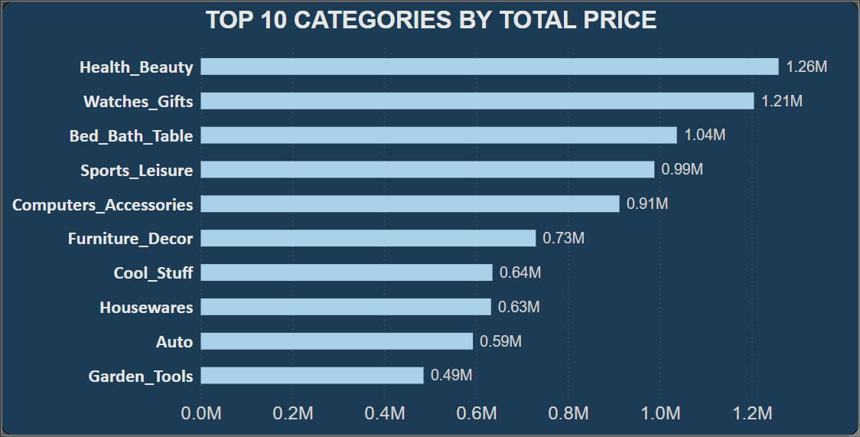

**DESCRIPTION: -**

**The above bar chart visually represents the top 10 product categories by total sales. Health and Beauty products are purchased more by customers which makes the total sales at 1.26M till date followed by watches & gifts, bed bath table, and sports accessories and a few more.**

**INTERPRETATION: -**

**Certain product categories such as Health & Beauty, watches & gifts, and bathing accessories sell more than the others due to various reasons like demand, popularity, competitive pricing, discounts, effective marketing, and positive reviews etc. To improve the sales of the product categories that are not in the list above, we can implement several strategies that include**

**1. Discounts and Promotions:**

* **Flash Sales: Organize limited-time flash sales to create a sense of urgency.**
* **Clearance Sales: Offer significant discounts on unsold inventory to clear out stock.**
* **Bundle Deals: Create product bundles that combine popular items with unsold products at a discounted rate.**

**2. Marketing and Advertising:**

* **Email Campaigns: Send targeted email campaigns to inform customers about the discounts and promotions on unsold items.**
* **Social Media Promotions: Use social media platforms to advertise special deals and reach a broader audience.**
* **Influencer Partnerships: Collaborate with influencers to promote unsold products.**

**3. Improve Product Visibility:**

* **Homepage Features: Highlight unsold items on the homepage or in a special "Deals" section.**
* **Search Engine Optimization (SEO): Optimize product listings with relevant keywords to improve search ranking and visibility.**
* **Sponsored Ads: Use paid advertising on platforms like Google and social media to boost visibility.**

**4. Enhanced Product Listings:**

* **High-Quality Images: Use professional, high-quality images to make the products more appealing.**
* **Detailed Descriptions: Provide detailed and compelling product descriptions highlighting the benefits and features.**
* **Customer Reviews: Encourage reviews and display positive customer feedback prominently.**

**5. Seasonal and Thematic Sales:**

* **Holiday Promotions: Align sales with upcoming holidays or seasons to attract more buyers.**
* **Themed Sales Events: Create themed sales events around certain categories or types of products.**

**DELAYED ORDERS ANALYSIS:**

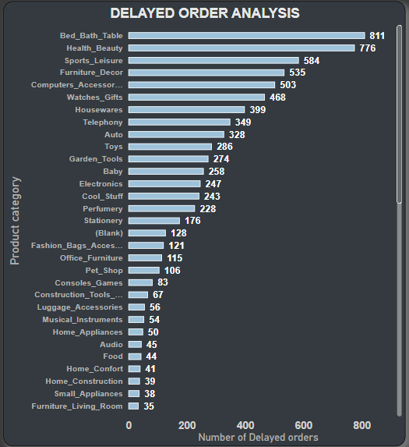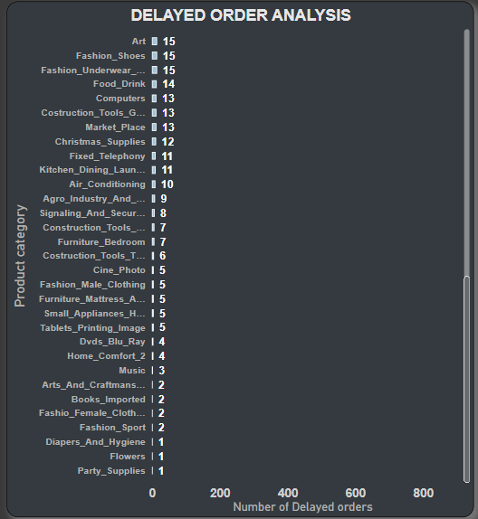

**DESCRIPTION: -**

**This bar chart represents the number of orders that were delayed in each product categories. These products were delivered later than the estimated delivery date.**

**INTERPRETATION: -**

**Certain products like bed bath table, health & beauty accessories, sports leisure, furniture decor etc were present in the top 10 products categories that were sold well, which could be the indeed reason they are experiencing delayed deliveries due to increased demand in products. The below are some strategies to be taken by us to minimize the impact: -**

**1. Transparent Communication:**

* **Notify Customers:** Inform customers about the delay as soon as possible through email, SMS, or notifications.
* **Provide Reasons**: Clearly explain the reasons for the delay to build trust and understanding.
* **Regular Updates**: Keep customers updated on the status of their orders with regular communication.

**2. Adjust Expectations:**

* **Set Realistic Delivery Times**: Adjust the estimated delivery times on the product pages to reflect the delays accurately.
* **Highlight Delays**: Clearly indicate which product categories are experiencing delays before the customer completes the purchase.

**3. Improve Logistics and Inventory Management:**

* **Optimize Supply Chain**: Identify bottlenecks in the supply chain and work with suppliers to improve efficiency.
* **Increase Stock Levels**: Maintain higher inventory levels of products that are prone to delays to buffer against disruptions.
* **Local Warehousing**: Utilize multiple warehouses in different regions to reduce delivery times.

**4. Partner with Reliable Carriers:**

* **Carrier Diversification**: Partner with multiple reliable shipping carriers to mitigate risks associated with any single carrier.
* **Expedited Shipping Options**: Offer expedited shipping options for delayed categories, even if it involves a higher cost.

**5. Improve Coordination with Suppliers:**

* **Strengthen Relationships**: Build stronger relationships with suppliers to improve communication and collaboration.
* **Emergency Protocols:** Establish emergency protocols with suppliers to handle unexpected delays more effectively.

**6. Leverage Technology:**

* **Inventory Management Systems**: Implement advanced inventory management systems to better track stock levels and predict potential delays.
* **AI and Data Analytics**: Use AI and data analytics to forecast demand and identify potential supply chain issues early.

**7. Review and Adapt Policies:**

* **Flexible Return Policies**: Offer flexible return and refund policies for delayed items to reduce customer dissatisfaction.
* **Partial Shipments**: If customers order multiple items, ship available items first and send the delayed items separately when they arrive.

**MONTHLY COMPARISON OF DELAYED AND ON-TIME ORDERS:**

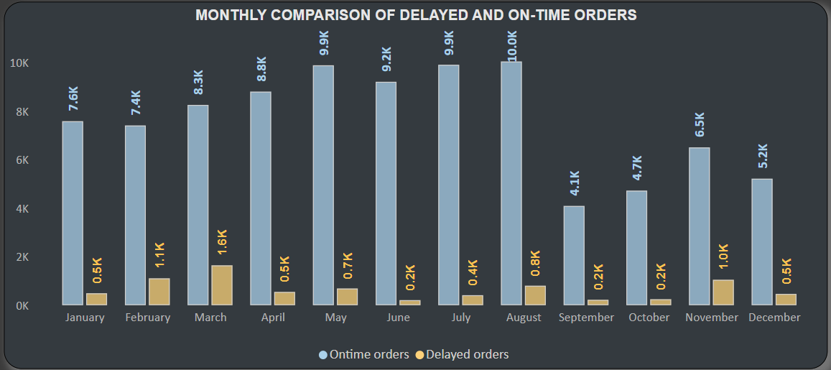 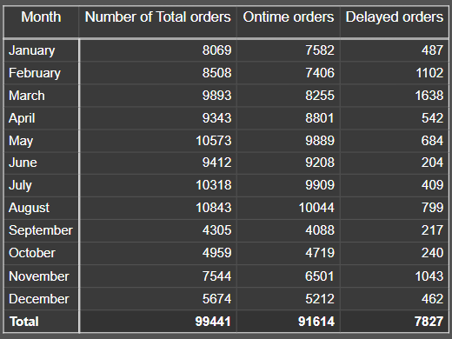

**DESCRIPTION: -**

**The above column chart compares the number of delayed and on-time order each month. The table shows the number with respect to the total number of orders received each month.**

**INTERPRETATION: -**

**1. Ontime Orders:**

* The total number of on-time orders over the year is 91,614.
* The month with the highest number of on-time orders is **August** with 10,044 orders.
* The month with the lowest number of on-time orders is **September** with 4,088 orders.

**2. Delayed Orders:**

* The total number of delayed orders over the year is 7,827.
* The month with the highest number of delayed orders is **March** with 1,638 orders.
* The month with the lowest number of delayed orders is **June** with 204 orders.

**3. Percentage of Delayed Orders:**

* The overall percentage of delayed orders for the year is approximately **7.87%.**
* **March** has the highest delay ratio (**19.8%**), indicating a significant issue with delays in that month.
* **June** has the lowest delay ratio (**2.2%**), showing better performance in timely deliveries.

**4. Trends and Patterns:**

* The summer months (June, July, August) generally have higher total orders and on-time orders, with relatively low delay percentages.
* There seems to be a notable spike in delayed orders in February and March, which may indicate seasonal challenges or issues specific to that period.

To improve delayed deliveries each month, several areas can be addressed, focusing on operational efficiency, supply chain management, and customer communication.

1. **Enhance Supply Chain Management:**
   * **Supplier Collaboration**: Work closely with suppliers to ensure timely delivery of raw materials and finished products. Implement Just-In-Time (JIT) inventory systems to reduce lead times.
   * **Diversify Suppliers**: Have multiple suppliers for critical products to mitigate the risk of delays from any single supplier.
2. **Optimize Warehouse Operations:**
   * **Automation**: Implement automated systems for inventory management, picking, and packing to speed up order processing.
   * **Staff Training**: Regularly train staff on best practices and efficient handling of warehouse operations.
3. **Improve Logistics and Delivery:**
   * **Reliable Carriers**: Partner with reliable shipping carriers known for timely deliveries. Have backup carriers to avoid dependence on a single provider.
   * **Route Optimization**: Use route optimization software to plan the most efficient delivery routes and reduce transit times.
4. **Invest in Technology:**
   * **Order Management Systems**: Implement robust order management systems (OMS) to track orders in real-time and identify bottlenecks.
   * **Predictive Analytics**: Use predictive analytics to forecast demand and adjust inventory and staffing levels accordingly.
   * **Customer Relationship Management (CRM)**: Use CRM systems to keep track of customer orders, preferences, and communication history.
5. **Enhanced Customer Communication:**
   * **Proactive Notifications**: Notify customers promptly about any potential delays and provide revised delivery dates.
   * **Transparent Tracking**: Offer real-time tracking of orders so customers can monitor their delivery status.
   * **Customer Support**: Enhance customer support to address any concerns and provide quick resolutions for delayed deliveries.
6. **Performance Monitoring and Continuous Improvement:**
   * **Key Performance Indicators (KPIs)**: Track KPIs such as order fulfilment time, delivery time, and delay rates to monitor performance.
   * **Regular Reviews**: Conduct regular reviews of delivery performance and identify areas for improvement.
7. **Seasonal and Demand Planning:**
   * **Seasonal Planning**: Anticipate and plan for seasonal demand spikes to ensure adequate staffing and inventory levels.
   * **Promotional Planning**: Coordinate promotional activities with inventory and logistics teams to avoid overwhelming the supply chain.
8. **Risk Management:**
   * **Contingency Plans**: Develop contingency plans for common issues like weather disruptions, strikes, or other unforeseen events that could delay deliveries.
   * **Insurance**: Consider insurance options to cover potential losses from delayed deliveries.

By focusing on these areas, retailers can significantly reduce the number of delayed deliveries, enhance customer satisfaction, and improve overall operational efficiency.

**PAYMENT METHOD ANALYSIS:**

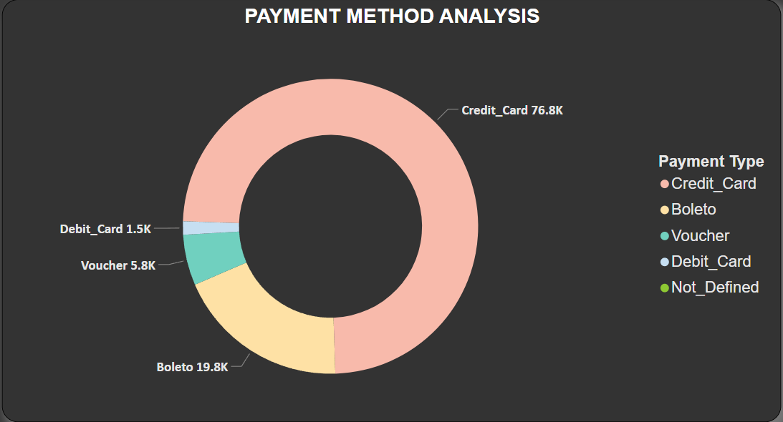



**DESCRIPTION: -**

**The above pie chart shows the distribution among the various payment options used by customers.**

**INTERPRETATION: -**

* The overwhelming preference for credit cards (**76.8K transactions**) suggests that ensuring robust, secure, and user-friendly credit card processing should be a priority for the business.
* The significant use of Boleto (**19.8K transactions**) indicates the importance of supporting regional payment methods, which can enhance the user experience and potentially increase sales in specific markets.
* The lower usage of vouchers and debit cards suggests that while these methods are used, they are not as prevalent. Efforts could be made to promote these options if the business aims to diversify payment methods or cater to specific customer segments.

**ACTIONS BASED ON INSIGHTS:**

* **Enhance Credit Card Processing**: Ensure that the credit card payment process is seamless, secure, and supports various credit card providers.
* **Support Regional Payment Methods**: Maintain and improve support for Boleto and possibly other regional payment methods to cater to local preferences.
* **Promote Alternative Payment Methods**: Encourage the use of vouchers and debit cards through promotions, discounts, or by highlighting the benefits of these payment methods.

Understanding the preferred payment methods helps in tailoring the payment gateway and checkout processes to meet customer expectations and improve the overall shopping experience.

**PRODUCT RATING ANALYSIS:**

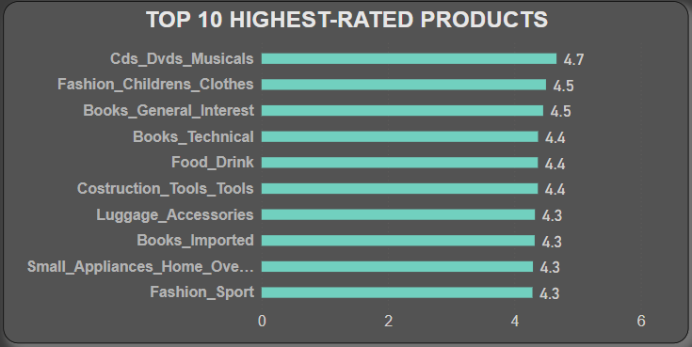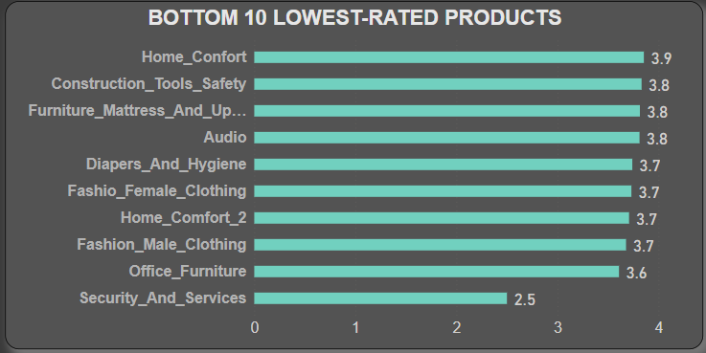

**KEY OBSERVATIONS: -**

* **Highest-Rated Categories**: Media products (like CDs, DVDs, Musicals), children's clothing, and various types of books (general interest, technical, imported) are among the highest-rated products, suggesting these categories meet customer expectations well.
* **Lowest-Rated Categories:** Categories related to home comfort (Home Comfort, Home_Confort_2), safety tools, and services (Security and Services) are among the lowest-rated products. The lowest-rated category, Security and Services, has a significantly lower rating of 2.5, indicating considerable dissatisfaction.
* **General Observation**: Products related to entertainment and books tend to have higher ratings, whereas practical, safety, and home-related products tend to have lower ratings.

This analysis suggests that customers are more satisfied with entertainment and children's clothing products, while there is room for improvement in safety, home comfort, and services categories.

**INTERPRETATION: -**

#### **1**. **Customer Feedback Analysis**

* **Collect Data**: Use surveys, reviews, focus groups, and direct customer interactions to gather feedback.
* **Analyse Feedback**: Identify common complaints, suggestions, and areas for improvement.
* **Prioritize Issues**: Rank issues based on frequency and impact on customer satisfaction.

#### **2**. **Quality Assurance and Improvement**

* **Supplier Audit**: Evaluate and ensure suppliers provide high-quality materials and components.
* **Manufacturing Process**: Implement stringent quality control processes during production.
* **Product Testing**: Conduct rigorous pre-launch testing to identify and fix issues.
* **Continuous Monitoring**: Regularly review product performance and address emerging issues.

#### **3**. **Design and Usability Enhancements**

* **User-Centric Design**: Focus on ergonomic and user-friendly design principles.
* **Feature Improvements**: Add or enhance features based on customer needs and feedback.
* **Ease of Use**: Simplify interfaces and provide clear instructions for use and assembly.

#### **4**. **Customer Engagement and Community Building**

* **Engage Customers**: Create platforms for customers to share feedback and suggestions.
* **Loyalty Programs**: Implement loyalty programs to reward repeat customers and brand advocates.
* **Community Building**: Foster a community around the brand where customers can interact and share experiences.

#### **5**. **Product Development and Innovation**

* **Market Research**: Continuously research market trends and competitor products.
* **Innovation**: Invest in R&D to develop innovative features and improvements.
* **Pilot Programs**: Launch pilot programs for new products or features to gather real-world feedback before full-scale release.

#### **6**. **Performance Tracking and Continuous Improvement**

* **KPIs**: Establish key performance indicators (KPIs) to measure improvement in product quality and customer satisfaction.
* **Regular Reviews**: Conduct regular reviews of product performance and customer feedback.
* **Iterative Improvements**: Continuously iterate and improve products based on ongoing feedback and performance data.

**STATE-WISE SALES ANALYSIS:**

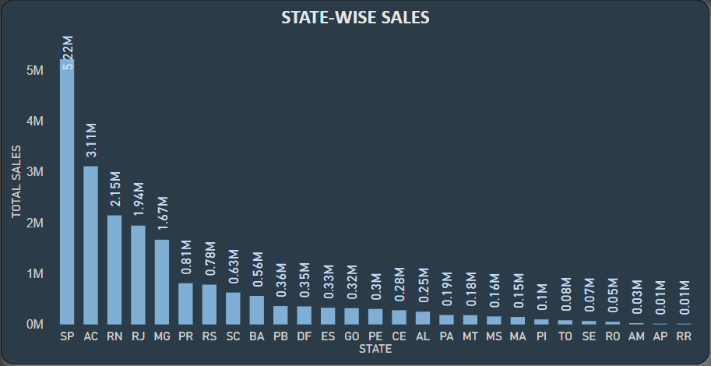

**KEY OBSERVATIONS: -**

The above visualized column chart displays state-wise sales data, showcasing the total sales volume for various states. The chart reveals significant variations in sales across different regions, with some states having exceptionally high sales and others significantly lower. **São Paulo (SP)** leads with the highest sales at **5.2M**, followed by **Acre (AC)** with **3.11M**, and **Rio Grande do Norte (RN)** with **2.15M**. The chart highlights the disparity in sales performance, indicating a concentration of sales in a few key states while many other states have much lower sales volumes, with the lowest recorded at approximately 0.01M.

**INTERPRETATION: -**

* **State with Highest Sales** 
  + - * + **2018**: São Paulo (SP) achieved the highest sales with 2.98M.
        + **2017**: São Paulo (SP) again, with 2.22M.
        + **2016**: No significant sales data recorded (0.01M).

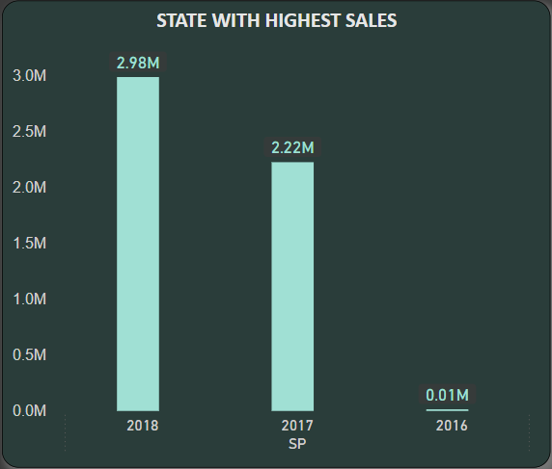

* **State with Lowest Sales** 
  + - * + **2018:** Roraima (RR) recorded the lowest sales with 0.01M.
        + **2017 and 2016:** No sales data recorded (0M).

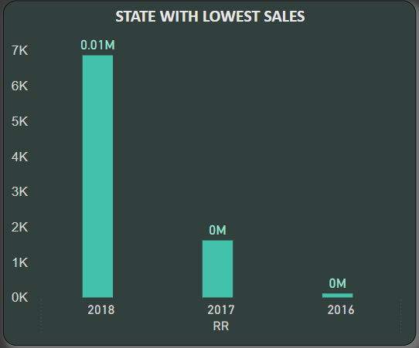

**SEASONAL SALES PATTERNS:**

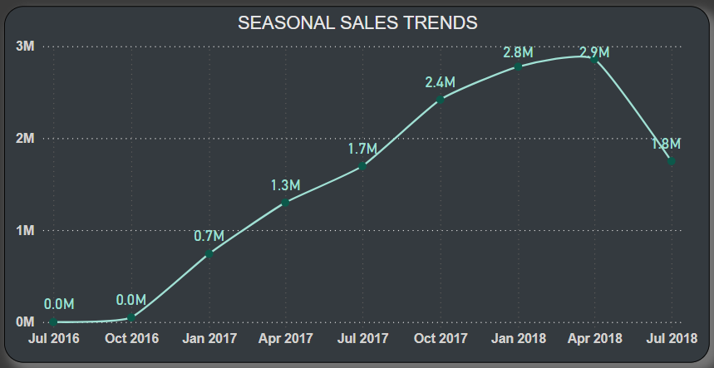

**KEY OBSERVATIONS: -**

**1.** **Initial Sales (July 2016 - October 2016)**:

* Sales started at 0.0M in July 2016 and remained flat through October 2016.

**2.** **Gradual Increase (October 2016 - April 2017)**:

* Sales began to rise in January 2017, reaching 0.7M.
* Continued growth was observed, with sales increasing to 1.3M by April 2017.

**3.** **Significant Growth (April 2017 - January 2018)**:

* Sales saw a sharp increase, reaching 1.7M by July 2017.
* The upward trend continued, with sales reaching 2.4M by October 2017.
* The peak was reached in January 2018 at 2.8M and slightly higher at 2.9M in April 2018.

**4.** **Decline (April 2018 - July 2018)**:

* Sales dropped to 1.8M by July 2018, indicating a significant decline after peaking in early 2018.

**OVERALL TREND:**

* **Growth Phase**: From January 2017 to April 2018, there was a consistent upward trend in sales, with several noticeable peaks.
* **Decline Phase**: After peaking in April 2018, sales declined sharply by July 2018.

**INSIGHTS:**

* The chart indicates a strong period of growth in sales starting in early 2017, peaking in early 2018, followed by a notable decline.
* The seasonal pattern suggests that sales may be influenced by specific factors or events occurring during these times, which could be further investigated to understand the causes of growth and subsequent decline.

**REVENUE ANALYSIS:**

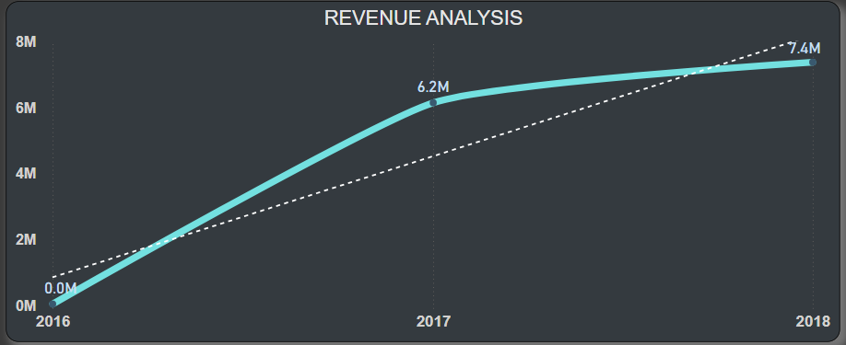

**DESCRIPTION: -**

The visual represents a revenue analysis from 2016 to 2018, showing actual and projected revenue trends.

**INTERPRETATION: -**

* **2016 to 2017 Growth**: The revenue grew significantly from **0M** in **2016** to **6.2M** in **2017**.
* **2017 to 2018 Growth**: The growth continued but at a slower pace, reaching approximately 7.4M in 2018.
* **Trend Lines:**
  + **Solid Line:** Indicates the actual revenue recorded.
  + **Dotted Line:** Represents the projected revenue.

Improving the growth rate of a company involves strategic planning and execution across various facets of the business. Here are some potential strategies:

**Market Expansion:**

1. **Geographic Expansion**:
   * **Domestic**: Enter new cities or regions within the current country.
   * **International**: Explore new countries or global markets where there is demand for your products/services.
2. **New Customer Segments**:
   * Identify and target new customer demographics that have not been previously reached.

**Product Development:**

1. **Innovate and Diversify**:
   * Develop new products or services that complement the existing offerings.
   * Enhance current products based on customer feedback and market trends.
2. **Technology Integration**:
   * Implement new technologies to improve product features, enhance customer experience, or streamline operations.

**Marketing and Sales Strategies:**

1. **Digital Marketing**:
   * Utilize social media, SEO, and content marketing to increase brand visibility and attract more customers.
   * Implement targeted advertising campaigns using data analytics to reach potential customers more effectively.
2. **Customer Relationship Management (CRM)**:
   * Strengthen relationships with existing customers through loyalty programs, personalized marketing, and excellent customer service.

**Operational Efficiency:**

1. **Cost Management**:
   * Optimize supply chain operations to reduce costs and improve margins.
   * Invest in automation to streamline processes and reduce human error.
2. **Data-Driven Decisions**:
   * Leverage data analytics to make informed decisions about inventory, marketing strategies, and customer preferences.

**Strategic Partnerships:**

1. **Alliances and Collaborations**:
   * Form partnerships with other businesses to leverage their strengths, expand market reach, or enhance product offerings.
   * Explore mergers and acquisitions to gain market share quickly.
2. **Industry Networking**:
   * Participate in industry events, trade shows, and networking groups to build relationships and explore new business opportunities.

**Customer-Centric Approach:**

1. **Enhance Customer Experience**:
   * Focus on improving the overall customer journey, from the first point of contact to post-purchase support.
   * Solicit and act on customer feedback to continuously improve service quality.
2. **Custom Solutions**:
   * Offer personalized solutions and tailor products or services to meet specific customer needs, thereby increasing customer satisfaction and loyalty.

**Financial Strategies:**

1. **Funding and Investment**:
   * Secure additional funding or investment to support growth initiatives, whether through venture capital, loans, or other financial instruments.
2. **Pricing Strategy**:
   * Reevaluate pricing models to ensure competitiveness while maintaining profitability.
   * Consider value-based pricing, discounting strategies, or subscription models.

**Talent and Culture:**

1. **Invest in Talent**:
   * Hire skilled professionals who can drive innovation and growth.
   * Provide training and development opportunities to keep the workforce motivated and competent.
2. **Cultivate a Growth Mindset**:
   * Foster a culture that embraces change, encourages innovation, and rewards performance.

Implementing these strategies can help accelerate growth and ensure sustainable development for the company. It's essential to periodically review and adjust these strategies based on market conditions, company performance, and emerging trends.

**CONCLUSION**

The ShopNest Store Business Analytics Dashboard provides a comprehensive and insightful overview of the company's performance across various metrics. By leveraging the power of Power BI, the dashboard effectively presents data in an accessible and visually engaging manner. Key insights include:

* **Customer and Order Metrics**: With 99.44K unique customers and 112.65K orders, the data showcases a robust customer base and significant order volume.
* **Sales Analysis**: Total sales amounting to 13.59M and a payment value sum of 16.01M highlight the financial health of the business. The detailed state-wise sales data reveals that SP leads with the highest sales, followed by AC and RN.
* **Product Performance**: The analysis of product categories indicates that Health & Beauty is the top-performing category by total price, while the highest-rated products include CDs, DVDs, Musicals, and children's clothing.
* **Delayed Order Analysis**: The dashboard identifies critical areas for improvement, such as the high number of delayed orders in categories like Bed, Bath, and Table, and Health & Beauty.
* **Seasonal Trends**: Sales trends show a peak in July 2017, with significant growth from early 2016 to mid-2018, reflecting the company’s strong market position over time.
* **Payment Methods**: Credit card usage is predominant, accounting for 76.8% of transactions, followed by Boleto and vouchers.

In conclusion, the ShopNest Store Business Analytics Dashboard is a powerful tool for monitoring business performance, identifying trends, and making informed decisions. It successfully combines detailed data analysis with user-friendly design, ensuring that stakeholders can easily access and understand key business metrics.

*********************************************************************************************************************************************